GRADE 7 ACCELERATED · UNIT 1 · LESSON 5  Solving Problems with Equations  Worksheet 7A.01.05 | Name_________________________  Date__________________________  Period________________________

For questions 1 and 2, rewrite the expression by applying the distributive property.
1. 6(x + 4)

2. (b − 9)(−4)

Equations of the form a(b + c) = d can be solved two ways: distribute the a first, or divide both sides by a first.
3. Solve 4(1 − 3x) = 52 using each method.
Method 1  Distribute first | Method 2  Divide both sides first
4(1 − 3x) = 52 | 4(1 − 3x) = 52

For questions 4 through 7, solve using your preferred method, then check your solution by substitution.

 | 4. |  | (x + 2) = 12

5. 0.2(r − 3) = −10

 | 6. |  | ( x + | 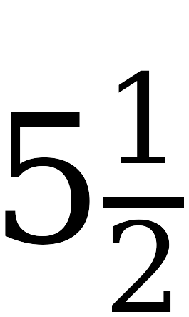 | ) = | 

7. 911.32 = 21.74p + 780.88

A local plumber charges a $75 fee for a home visit plus $66.24 per hour while working. The total bill was $339.96.
8. Write an equation for this situation. Use h for the number of hours the plumber worked.

9. Solve the equation.

10. Explain what the solution means in this situation.

